THIS ARTICLE SHOWS HOW TO MAKE CHEAP OIL EFFECTS WHEELS FOR YOUR GROOVY PROJECTOR – BRING BACK THE 70s.
Please read through the whole article, if only briefly, before you start.
Oil wheels first appeared in the 60s as many bands experimented with psychedelic effects, like wow, far out man.
Back in the 70s the ultimate projector to own was the Rank Tutor II. Times have not changed. It is still sought after as the best and any Ebay search will tell you, and with a wheel and rotator they fetch impressive prices. The original wheels are still being made but as in the 70s, are still expensive, as are the rotators.

The wisdom of those 60s sages was that glass must be used, mainly because Perspex could discolour and the oils would not flow over Perspex. To a small degree they were right but Perspex/acrylic has come a long way since then. After five years mine are still as good as when they were made and the oils flow nicely. OK, I have an original and it is better, but for the cost, is it four times better ? No.
The photos in this article show what they can do. Judge for yourself. Remember, after an initial outlay of less than £50 (depending upon certain choices and what you have or can scrounge) you will have the material to make at least five wheels.

Changing wheels during light shows for bands and discos involved loosening tiny grub screws on the wheel boss. As a DJ I had one Tutor and one wheel but a band I worked with from time to time used eight, often on wobbly scaffold...but hey, we hardly knew where we were, let alone what we were doing.

So I have designed a simple magnetic system ( I have six Tutors and eight or so wheels this time) for easy swapping of wheels. This is detailed in this article if you want to use it. You will need a jig for the Perspex unless you really want to cut it all ‘free hand’ – good luck with that.

- What you need.
- Building the jig, cutting the Perspex.
- Assembling the wheel
- Gluing
- Filling the wheel
- The magnetic attach system.
- Tips

Copyright Mike Houghton (c) 20013. This article may be copied and distributed freely.
What you will need.

A jig
Sheet of Perspex/acrylic
Masking tape
Felt tip pen,pencil,compass
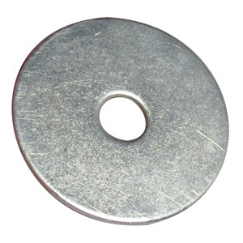
4mm nut bolt washer
4mm countersunk screw
2 X 3mm screws
3mm tap
4mm tap
Repair washer
Blue-Tack
Araldite – slow and Rapid, see also TIPS (to save more money)
Food colouring, Red,Blue,Yellow (why no green ?)
Bottle of clear glycerine (cheap, Boots)
Bottle of baby oil (cheap as you can get)
Some liquid candle dyes or oil colours: Red,Blue,Yellow
Three or four cheap syringes with 1mm applicators.
A roll of black PVC tape, about 2-3cm wide (electricians tape)
A projector at least !
Motor
Magnets
Small piece of thick aluminium

This list may look rather daunting but it isn’t really. I just tried to list everything possible. Many odds and ends you might have already, or can beg or steal. More details for these bits crop up as needed in the text.

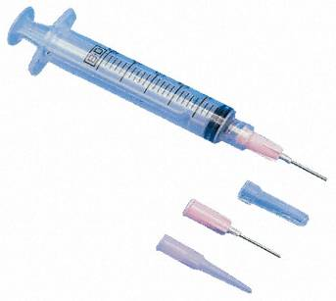
You can get food dyes at any supermarket. It takes a bit of searching but you will find oil colour on ebay. It is not cheap but you will not use a lot of it. To really save money you can just buy red and blue.
The syringes are not like medical ones really, more like the applicators some glues come in and the needles are called applicators. I bought three syringes and five 1mm applicators and have never needed more.

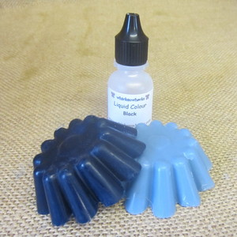

This is some dye from ebay, listed as:

10mls BLACK Liquid Candle Making Aroma Beads DYE.

10mls are all you need for now

THE JIG
Perspex
3 inches
Wood base
Hole in middle
Nail through base

Metal bar
Sharp screw

First, cut a rough circle from the Perspex, B&Q do a good size 3mm sheet for about £15.00. You will get five or six wheels from this. IMPORTANT – DO NOT REMOVE THE FILM COVERING !!! Draw a 6 inch circle on the covering and mark the centre – use a compass. With a felt tip pen draw a rough circle as best you can around the first one, about 1-2cm bigger all round. Inches, cm...yes I know.

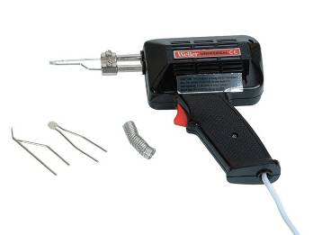
Rough outline
Weller gun.
Use cutting bit
Cut around rough line
6 incircle
Perspex
Distance from blue outline to
Actual circle should be about
1 cm

Once cut from big sheet use a small saw to cut down to the score line, all around circle with gaps of about 2-3cm-no more!
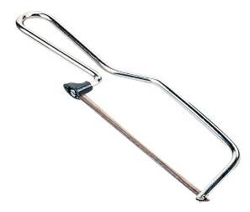
When this is done, go around the edge and gently snap off all the pieces to leave you with a circle. You will find that most of the pieces tend to ‘hang’ by the protective film. When all are off simply run around with a Stanley knife to free them. Make 3 discs.
Piece snapped out

With three discs ready we can begin to assemble the wheel. You can use only two discs for a first go and just make a two colour effect if you like.

ASSEMBLING THE WHEEL

You must select which disc will be in the middle. Strangely, I have found that if you place the three discs in a stack, there seems to be a sort of warp and depending how you stack them you can get an even spacing. When you have decided – and this is a vital step, remove the covering film from the outside of the front and back discs with masking tape, then trim to the edges. Remove all the inner films and clean the inner surfaces with a little meths. DO NOT TOUCH THE INNERS SURFACES ONCE CLEANED.

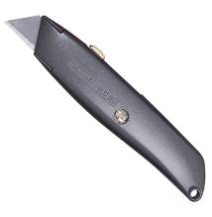
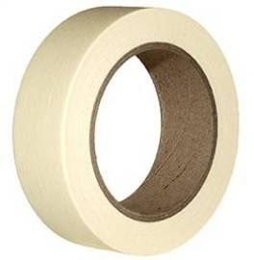

When at B&Q, buy two or three of these. They are called repair washers and there are two sizes – get the larger size.
The most expensive item is Araldite – you need both types really, fast setting and slow setting. You will also need some kind of spacer, 1-1.5mm thick. I use some plastic card that luckily has adhesive on one side, but before that I just cut plastic from anything I could find. Cut two spacers from the plastic, the same diameter as the washers. Apply a thin smear of Araldite to the spacers and carefully place one in the middle of the middle disc, one on either side.

Now you have the bits to assemble a wheel – you also have a lot of stuff already for a few more! I made many until I got it right – you are spared all that because I will explain how to make every wheel good.

One reason for the washer is to use the magnetic release system. You may like to scan all of the instructions first in case you do not want to do this too and prefer to use your own method. The washer also helps in holding the discs together.

Time to assemble the parts. Drill 4mm through all the parts if you have not already done so.
Find a 4mm nut and bolt, anything will do. You should have three Perspex discs with a spacer either side of the middle disc. A short piece of wire placed NSEW will provide a reasonably consistent spacing – doesn’t need to be perfect. A 4mm bolt passes right through and a temporary washer to protect the Perspex from cracking is one the nut side. A repair washer is on the ‘front’ disc.

Apply a smear of slow araldite to the already positioned spacers.
When the centre spacers are fitted, smear Araldite on the two exposed sides of the spacers and assemble the stack
This is any old wire you have that is about 1-1.5mm diameter. Use four pieces per disc, NSEW
Bend the wire over and tape the end down

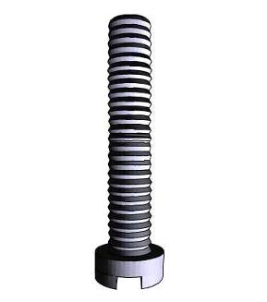
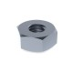
Araldite or double sided tape
Temporary washer
Repair washer
THE MESSY BIT NOTE: From now on the bolt is still in place!
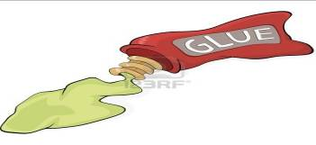
Use slow Araldite and go right around both discs
Choose any two wires, one on each disc, that are NOT opposite each other
At the two chosen wires do not got right to the wire –leave a gap of around 10mm – this is where you will fill the wheel.
GOOD
BAD

A piece of plastic is very useful here to gently press the glue in. The depth you want is only a few mm to make sure it seals, certainly no more than 5mm is all you need. As a rough guide, 4cm of adhesive and 4cm of hardener should just do the job. Do not worry if the glue seeps over onto the masking tape – that’s why its there! You should use the plastic to smooth the glue right to the edge of the plastic and not leave it proud. To save money you can skip the Araldite and use silicone bath sealer. For the spacers something like Evo-stick should work, the function of the glue is only to seal the spacers so that oil does not leak past them to the hole in the middle, and so far, after five years, it never has.
Lay it on its face and leave it. Because of the bolt it is best to lay it on the masking tape roll so that it is level. After a few hours the Araldite will tend to seep down the sides of the wheel. When this happens use your spreader to even it all out again. This needs to be watched every few hours during the day by which it will have begun to go off and can be left to finish while you got to bed.
Seepage, use spreader to make it even again

THE NEXT DAY....
I designed these wheels to save money. I was out of work and building a disco for something to do. Motors to turn them are very expensive, as are the wheels. I use motors from microwave cookers. These come in two types: metal shaft and plastic shaft, and are very cheap. I found the plastic shaft type pretty bad. The shaft on these is 6-8mm. With your Stanley knife carefully cut around the very edge of the wheel to remove and glue/sealant that is there. Then (I use a bench grinder) file away around the edge, right round, to get a reasonably smooth edge. And now (fanfare) peel away the masking tape!
If you are going to use another method of fixing then you can skip to the FILLING THE WHEEL section.
If you have not skipped, then you need to do a couple of things before you can fill the wheel. You will also have to make the bit that goes onto the projector which is at the end of this document. You can do this now, or later. With the assembly still bolted together carefully drill through as shown. Only the repair washer needs to be tapped. The spacing of the 3mm holes is up to you, but ideally both should be same distance from the middle, on the same axis, nearer to the edge of the spacer than to the 4mm hole.
3mm TAPPED
4mm
Repair washer

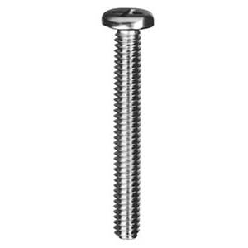
When you have done this, put two 3mm screws with washers through and tighten. One of the screws should be filed flush to the washer, the other should by 5-10mm over. Now you can remove the 4mm bolt – some of the araldite may have bound to it so you may have to unscrew it. Run the 4mm drill through afterwards to clean the hole

Carefully remove all the spacer wires except the two where you left a small opening. Be sure you don’t rip out the Araldite with the wires. If you are reading this through first, then a wiggle of those wires last thing before you leave it overnight , helps when you need to remove them.
Now you have two wires left. Mix a small amount of fast-set Araldite and seal the holes where you removed the wires. Mix the glue and keep testing it before you use it. After 5-10mins the glue will become thicker as it begins to set: this is when to apply it, you have about 5 mins. If you do not wait then the glue can run right down into the wheel.
It is time for your creative part. First, because Glycerine/food dye is cheap, this is always used as the main colour and the baby oil/candle dye is the other. With this wheel we have two sides to we need two colours in each side ( ie 1 oil and 1 glycerine each side). Less is best so you will not use a lot of liquids. If you think about colours, blue and yellow make green, red and yellow make orange, blue and red make purple. The shades depend upon the mix but again, I have found that it is best to make the colours as dark as possible. You will never ever be able to make two wheels the same.
I have some small bottles in which I keep made up colours so you need to make yours up. Make no more than 20 or 30mls of each oil. Make them as dark as you can without the dye thinning the oil too much. Make up as much Glycerine as you like.
This is a good start before you begin to experiment. First, with some tape, cover one of the openings. This is so that nothing from one side can accidently get into the other side and ruin it! (as I have done...)
With a syringe load about 1 syringe full of yellow Glycerine into the opening of the wheel until the level is about the same as shown.
GLYCERINE

With another syringe add some red oil to about the levels shown. Too much does not work as well as keeping just below the washer.

Use some blue-tack to seal the hole (this is temporary) so slap it on. Fit the wheel to your projector and let it turn a few times – you may lose a drop or two if the blue-tack is not applied very well, but that is no problem.
Now trust me! If it looks good then it IS good. The more you think you can get it better the worse it will get but you CAN make adjustments. You can shake some out by removing the blue-tack. You can darken the colours by injecting only colour, a bit at a time. When you are happy you need to seal the hole. Make sure that it is really clean with a tiny drop of meths and kitchen towel so that you can swab just inside the wheel. Finally, seal with Rapid Araldite with the same technique of testing for the point when the glue thickens as you did with the wires. Once set give the wheel a few more spins to make sure it does not leak.
Happy ? Now remove the tape covering the other hole. This time load in (similar levels to the first side), Red glycerine and blue oil. Use the blue-tack etc to spin and maybe adjust the colours, then seal.

Finally, I recently found that running silicone sealant around the edge is a good idea and in fact, sealant is probably better than Araldite because it has a bit of give. I used Araldite because I had a load left from a few years ago...don’t ask.

Take the PVC tape and with practice you will be able to stretch it around the edge such that it also covers a few mm of the discs. I usually go around three times. Then, it is done. Now you can remove the 4mm bolt, pass a 4mm drill through the wheel.

It is IMPOSSIBLE to drain a side, clean it out and re-fill if you make a mistake. Once, I put two oils in the same side, disaster! No matter what you do, some residue gets left. The ONLY answer is to take it all to pieces, recover the discs (not the spacers) and start again. If a wheel develops a small leak then just clean the area and seal it again. In five years I have done this maybe four times.
In the photos see how the wheel with less oil is by far the best, although they all change as they get warmer and the oil thins a bit.

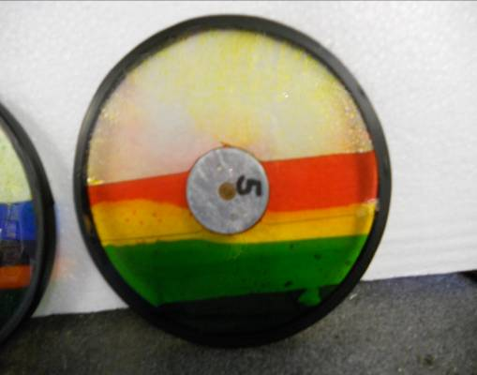
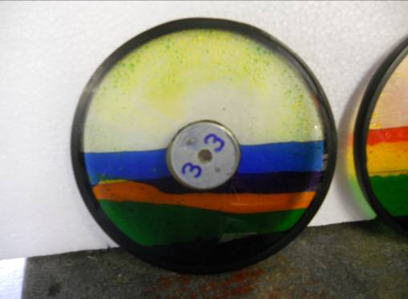
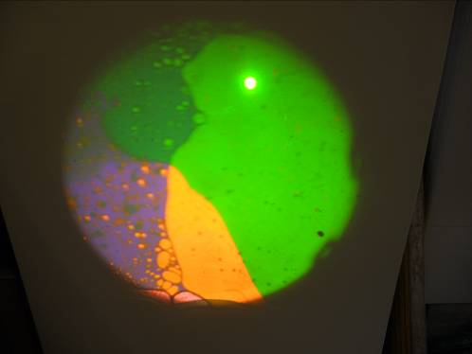
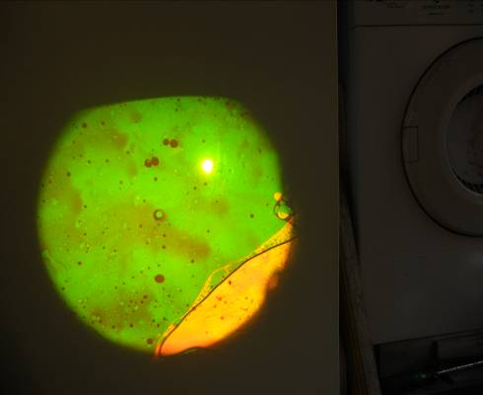

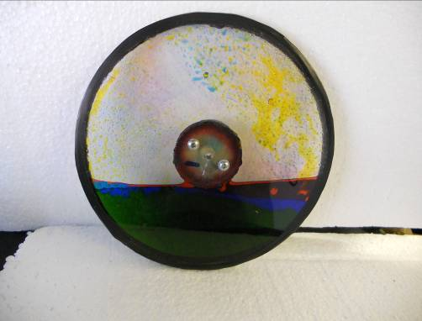
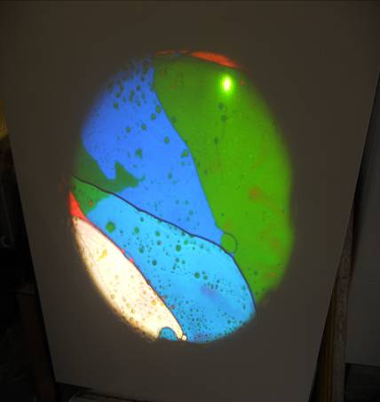
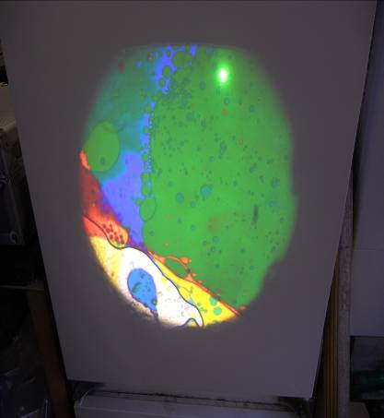
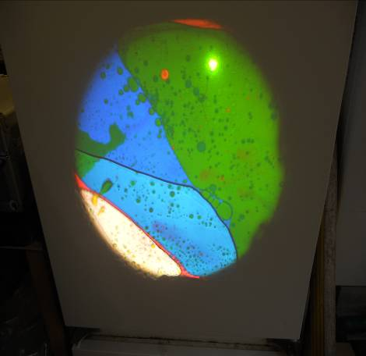

THE EASY CHANGE SYSTEM
This is the quick change magnetic system I designed. Over five years none of the parts has broken or needed gluing again etc – so it works. At any angle no wheel has ever come off.
For this you will need a piece of aluminium about the same thickness as the magnets, and the same size as the repair washers. I just cut a square an lop the corners off. The magnets are shown in the diagram.
The magnets are simple pressed into the aluminium with a vice. Careful filing out of a hole that is just under the correct size works best. If a bit loose then superglue will hold them (dribble some in from the back. Make sure the face of the magnet is flush.
The small hole (3-4mm) must line up with the longer screw on the wheel. The best way is to make up a washer first and then use this as a jig for all fittings. Then any wheel fits any projector.
The small slot is so that a small screwdriver can be used to break the magnetic bond – those magnets are very strong.
The centre hole in the aluminium plate is countersunk and tapped to 4mm, then a 4mm screw is fitted such that the screw protrudes about 5mm from the front; the back is the side with the boss.
A suitable boss must be fitted as shown – I found some old knobs with brass inserts. The inserts were easy to remove, then drilled out a fraction to fit the motor. Simples.
All of this should be clear in the diagram and the photos.

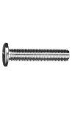
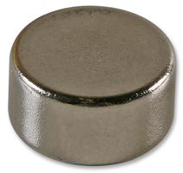
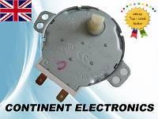
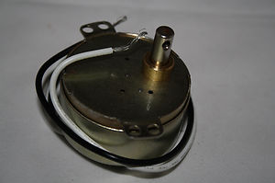
.
Bush glued to alu.
Superglue
Araldite

Farnell 188096
12mm magnet

Countersunk 4mm screw. Aluminium
Is tapped to 4mm
Aluminium shape. Same thickness (more or less) as magnets.
6-8mm diam shaft
Bad motor
Good motor
3-4mm hole lines up with long screw on wheel
Release groove
Area of repair washer on wheel

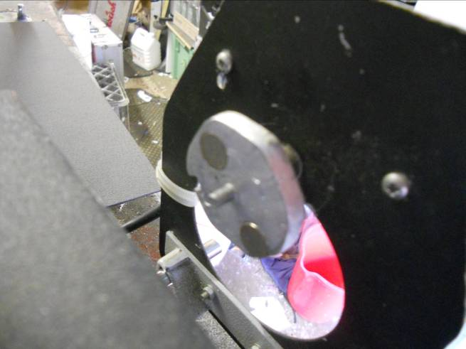
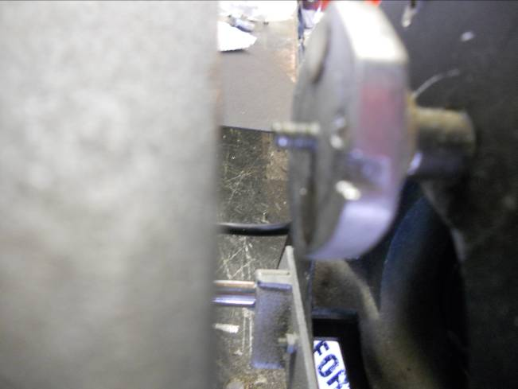
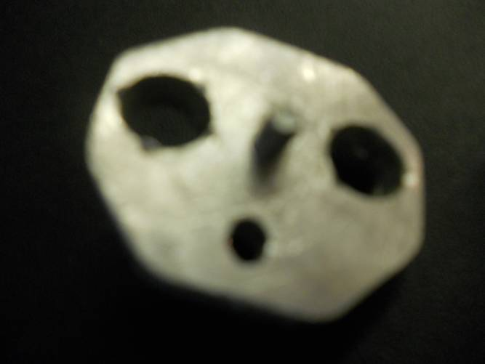
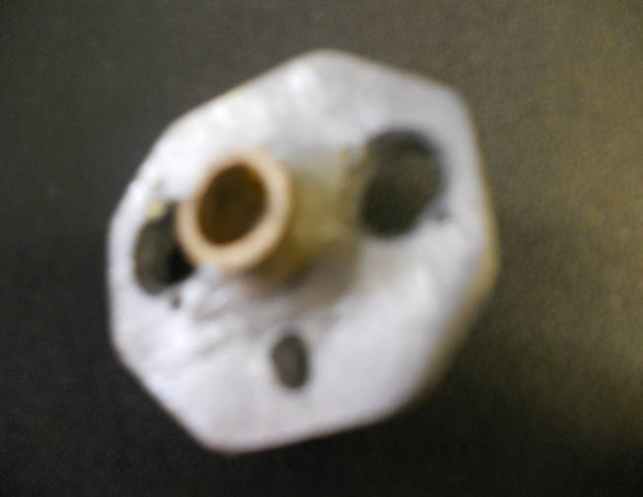
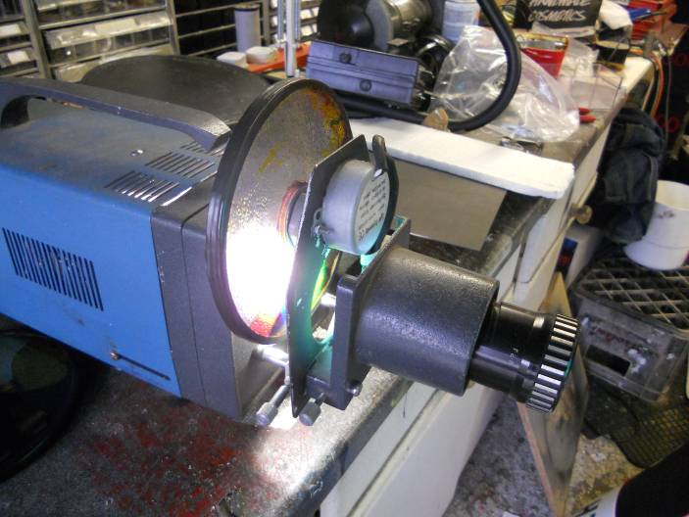
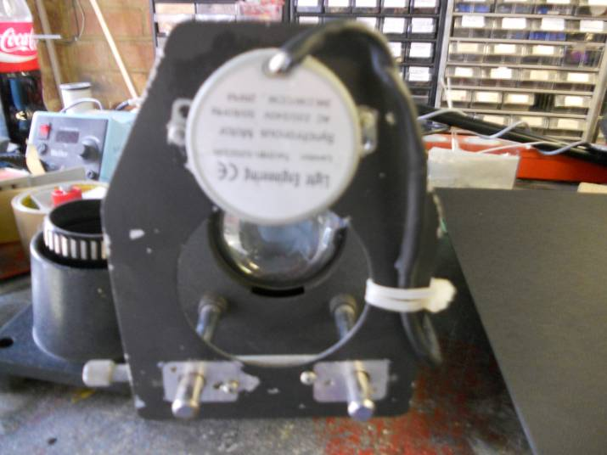
Trying for really close shots has blurred the photos but you should be able to see the details with reference to the diagram.
Release slot
This also shows and easy to make motor unit for the tutor. Simply cut down the slide attachment and screw an aluminium plate to it. I used a (wood!) hole saw to make the big hole

HINTS AND TIPS
I hope to have covered just about everything in the article so you may find some stuff repeated here.
You can try bathroom silicone sealant to go around the edges of the discs. If you get the fast drying stuff you could do the whole wheel in a few hours. Then, all you need is some Araldite Rapid or even a good adhesive.
Small leaks are best fixed with a little Araldite but I fixed some recently with sealant and they are fine.
When drilling Perspex do not use a new very sharp drill because it will bite into the material and could crack it.
Use washers under the 3mm screws that screw into the repair washer.
To make your own fixing, do everything but make both 3mm flush. Then you can fit your boss onto the aluminium.
When colouring the liquids just do about enough for the wheel and try not to thin the liquids too much.
Clean the syringes and applicators thoroughly and rinse with Fairy liquid to be sure, to be sure.

If you have sweet little Grand-children get yourself invited to Sunday lunch (it’s free). Offer to change baby and make sure you slip the Baby oil into your handbag. Recommend Glycerine for nappy rash (if there is none use a red felt tip), then repeat the following Sunday – and nick the Glycerine.
Drop into your local addict’s clinic and blag a few free syringes.
Felt tip pen, pencil, compass from your kid’s school bag, so they might get a detention – double result, you get some peace. When they get home, slip them back in their bag, then you can stop their pocket money for a week for being careless. Win,win,win.

If your neighbour is having a new kitchen/bathroom, go and admire it (lots) keeping an eye out for some black tape, masking tape and sealant. If your neighbour has a new greenhouse wait until dark. Modern greenhouses tend to use acrylic sheet rather than glass. You only need two or three panes.
The oil colouring used in oil lamps is obviously just as good as candle dye. Pop into your local Church in case they have used some. If you manage to find some there, three Hail Marys should do the trick.
Children’s toys, particularly not your children, are a good source of screw – you should find a 4mm or two on their bikes. Bless.

Let me know how you get on.

